**Complex SQL queries**

**Why are they complex?**

Because they involve fetching records or values from other queries sometimes within same table and sometimes with join operations.

**Types of subqueries**

1. **Scaler**
   1. Gives a value after running the query and this value is used as a reference in other outer query
2. **Multiple row**
   1. Gives records as a result on running this query and this record with multiple columns is used as a reference for other outer queries
3. **Correlated** 
   1. Gives records as a result and the inner query is run multiple times as it is related to the outer query.

**Q. Select all the movies with minimum and maximum release_year. Note that there  
can be more than one movie in min and a max year hence output rows can be more than 2.**

Solution:

Here, the inner queries return two values which are utilised by outer query to give result.

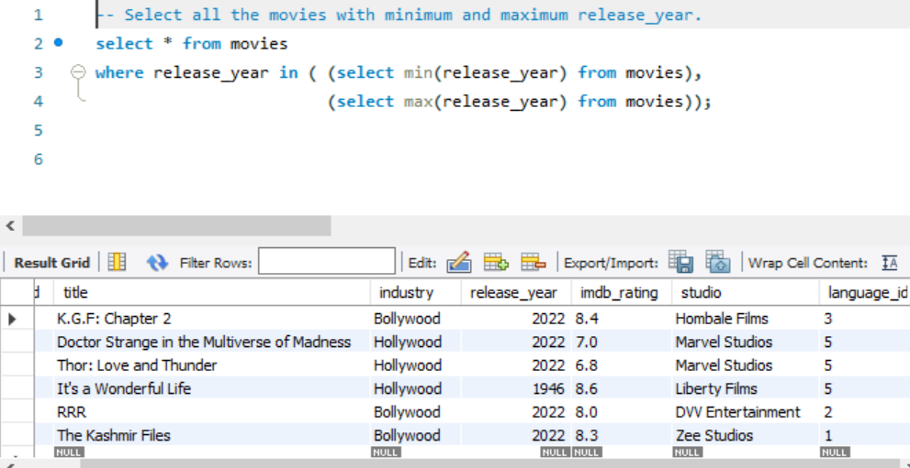

**2. Select all the rows from the movies table whose imdb_rating is higher than the average rating.**

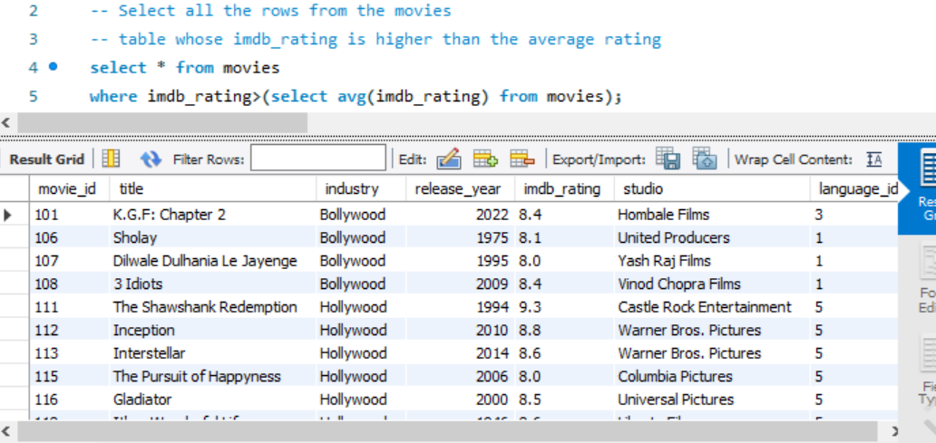

**3. Generate report of all Hindi movies sorted by revenue in millions**

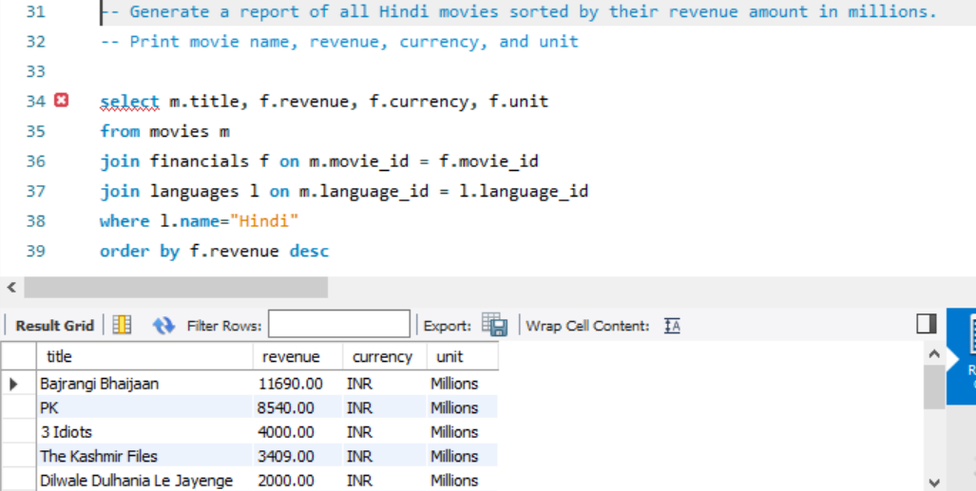

**4. -- select all actors whose 70 < age <85**

**-- way 1 , new column age gets added**

**-- way2, through subquery**

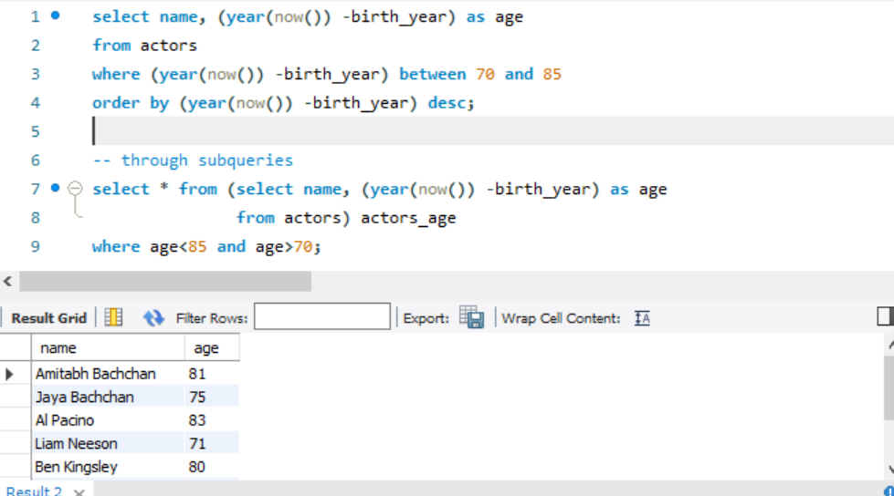

**5. Select all Hollywood movies released after the year 2000 that made more than 500 million $ profit or more profit.**

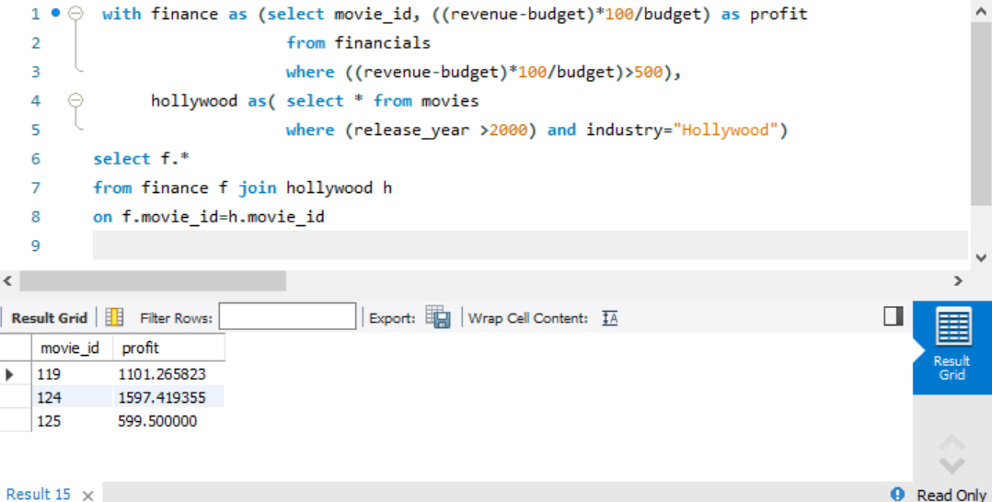

**6. select most youngest and oldest 3 actors from movies database**

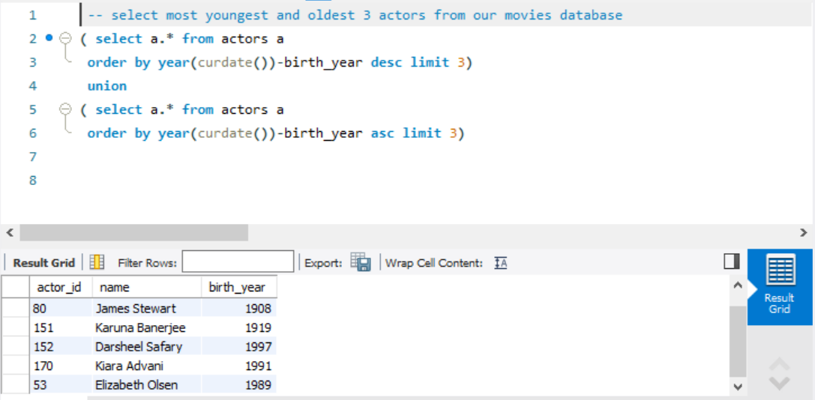

**7. For the salaries table below, write an SQL query that can print all the employees whose salary is greater than the average salary in the department**

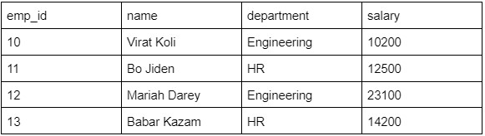

with avgsal_per_dept as (select s.* ,avg(salary) as avg_sal from salary s group by department)

select s.*, s.avg_Sal

from salary s join avgsal_per_dept a

using(department)

where f.salary > a.salary

**Similar question but different data.**

**Find revenue greater than avg(revenue) within a particular currency**

